Exercise 1 Look and write

|  |  |  |  |  |
| --- | --- | --- | --- | --- |
|  | Káº¿t quáº£ hÃ¬nh áº£nh cho black   clipart |  |  | Káº¿t quáº£ hÃ¬nh áº£nh cho white  clipart |
| *…Red* | *black* | *blue* | *green* | *white* |

Exercise 2 Look and match

e.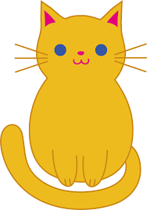

f.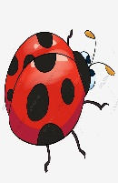

g.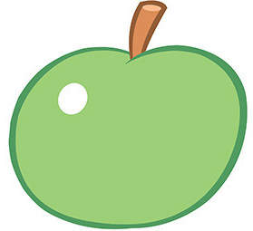

h. 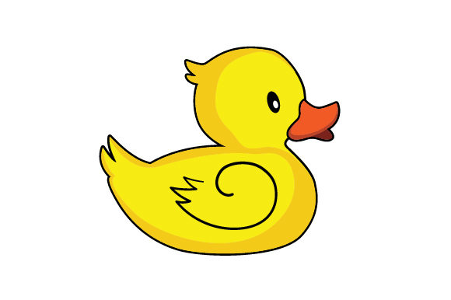

a.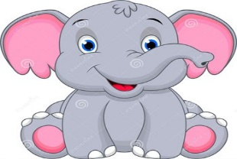

b.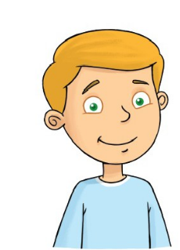

c.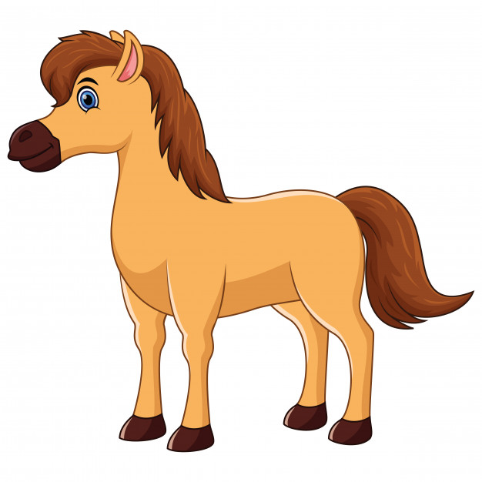

d 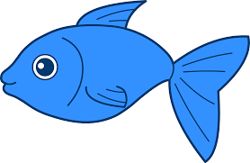

A

B

C

D

E

F

H

I

Exercise 3. Look and write the missing letters

|  |  |  |  |
| --- | --- | --- | --- |
|  |  |  |  |
| Balloon | apple | Puppet | car |
|  |  |  |  |
| boy | Chair | Teddy bear | Crayon |

Exercise 4. Look and write

|  |  |  |
| --- | --- | --- |
|  |  |  |
| four | one | three |

Exercise 5. Look and write

1. Yes, it is. b. No , it isn’t. c. No , it isn’t.